Udagram Project

Development Server

npm run dev

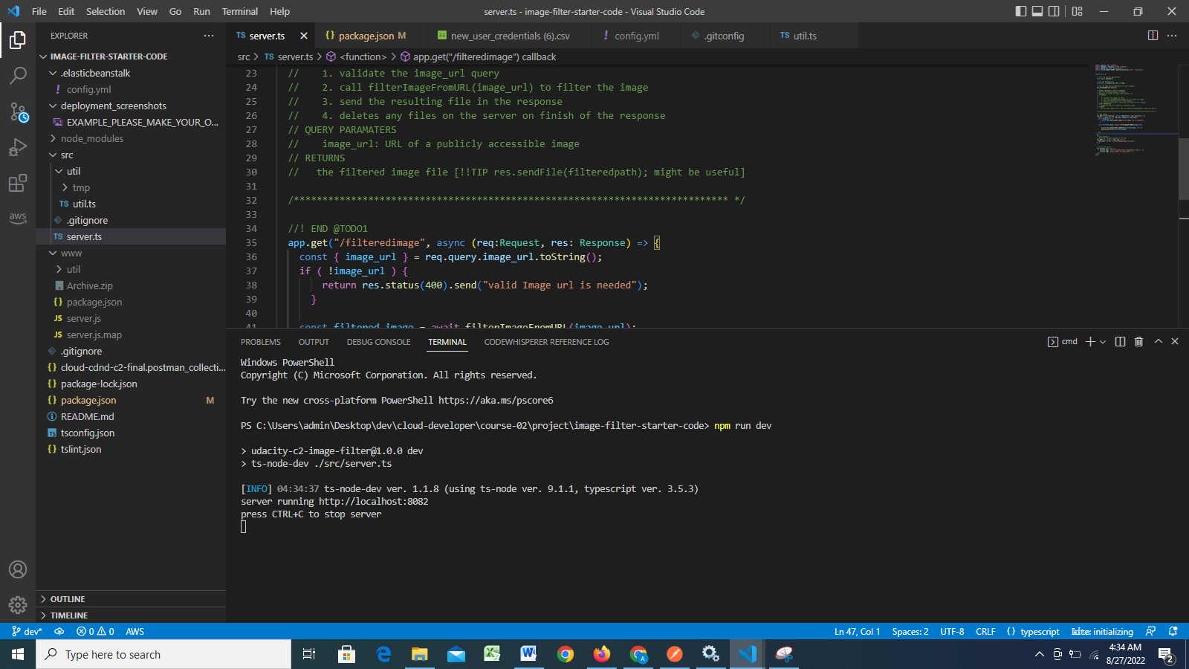

Testing api

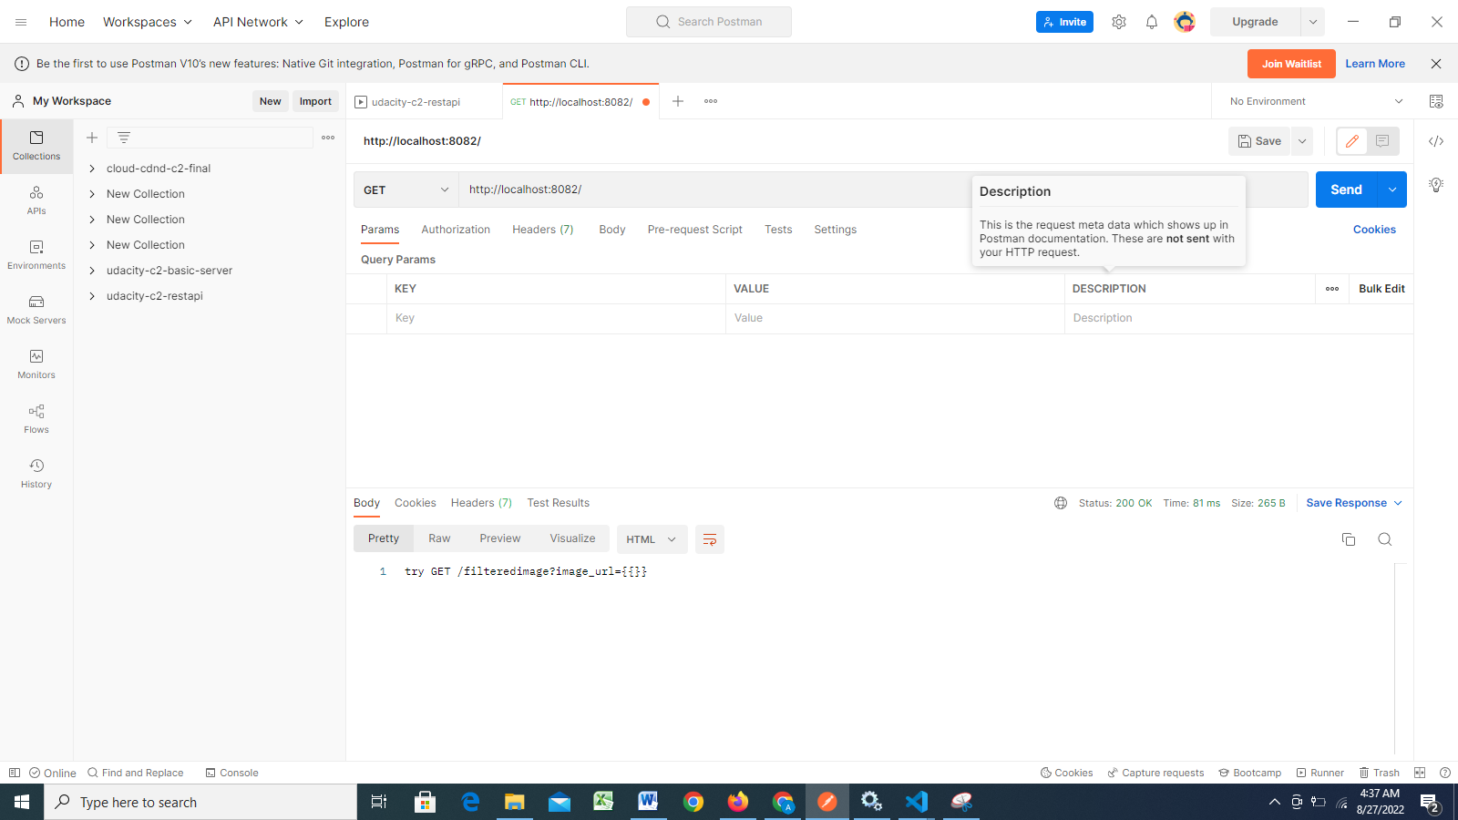

Elastic Beanstalk Deployment

eb init

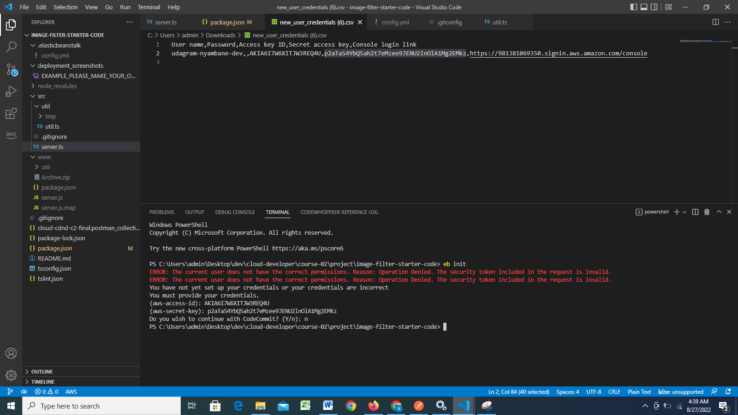

eb create

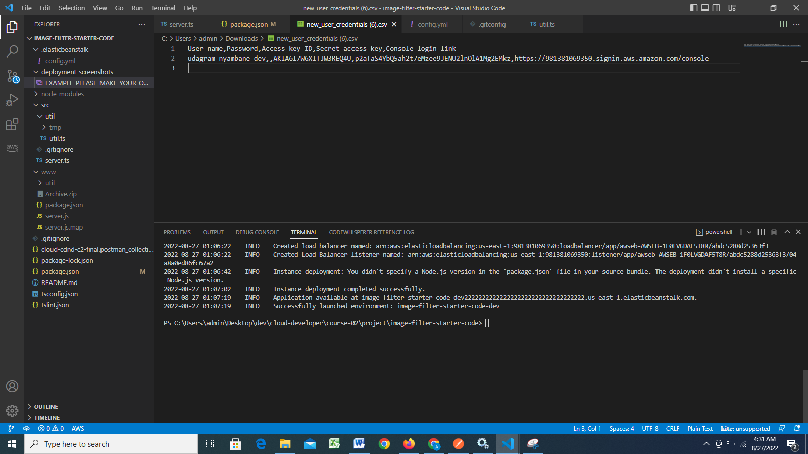

Eb deploy

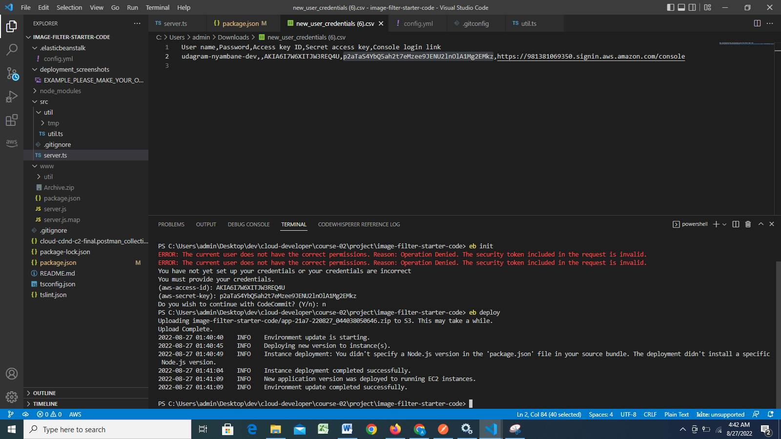

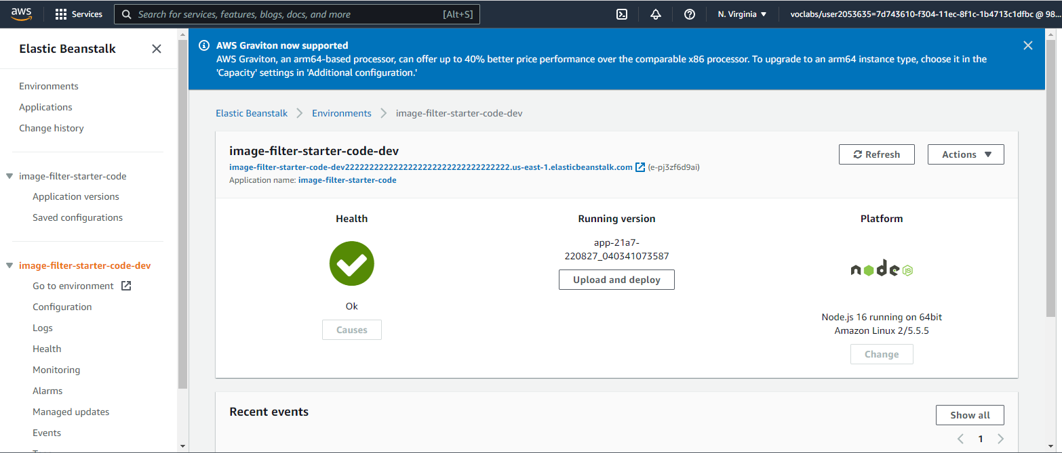

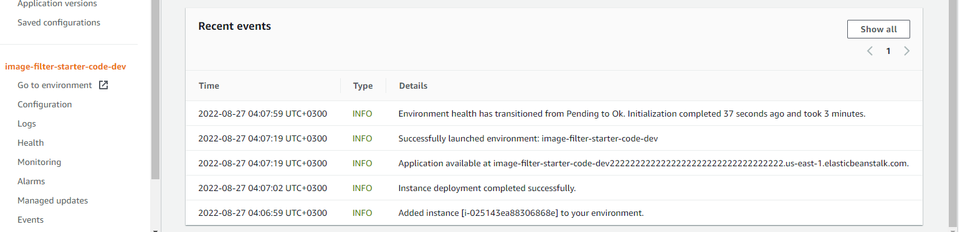

Engineering Process and Quality

<https://github.com/nyambaneA/cloud-developer/tree/main>